# Animal Help

Create a Web page (HTML5 + CSS3 + images) that looks like the screenshot below:

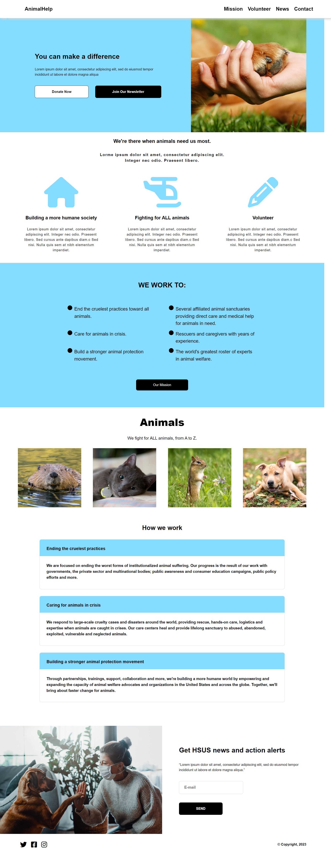

You are given the screenshot above + all required images.

### Output

The output should be valid **HTML5** + **CSS3** + **images** that implement the web page above.

### Constraints

* Use the following font: "Arial, sans-serif".
* The site should open correctly in the **latest** version of **Chrome**.